**Convolutional Neural Network to determine cat vs dog**

**Framework** – Fast.ai

**Knowledge transfer –** resnet34

**Data set** - <http://www.robots.ox.ac.uk/>

**Step 1:** Install pytorch and fastai

**Step 2:** Update the classification to Cats/Dogs and generate data set of Dogs and Cats

**Step3:** Generate batch size of 1

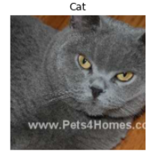

**Step 4**: Learn using resent34 algorithm and use Entropy loss function and then show results

